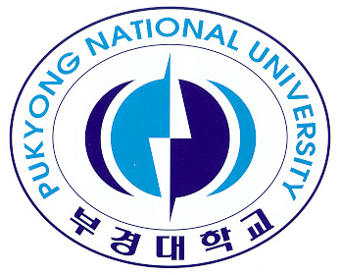 | The International Conference on Underwater Acoustic Technology and Education For Sustainable Fisheries in Asia  THE FIFTEENTH ANNUAL MEETING OF ASIAN FISHERIES ACOUSTICS SOCIETY, AFAS 2022  14th – 16th November 2022  Pukyong National University, 45, Yongso-ro, Nam-Gu. Busan, Korea | 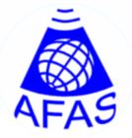
REGISTRATION FORM
Title (Prof / Dr / Mr / Mrs / Ms):
Name(Given/Surname): Gender:
Eligibility for the Award: ( Please leave the appropriate one. )
YFAA (under 40 years old), BSPA (Students), Not applicable (Others)
Affiliation / Employer:
Address:
Occupation/Position:
Email: Fax:
Title of Paper:

Preferred Presentation (Please leave the appropriate one) : Oral, Poster
Preferred session code to present (Please leave the appropriate one):
1. Acoustic Technology, 2. Theory and Target Strength, 3. Acoustic Application,
4. Acoustic in Marine Ranch and Fresh Water, 5. Others

[HOTEL INFORMATION] Only the following hotel will be reserved by the meeting secretariat.
Name : Education Training Institute
Check-in date: 12, 13, 14, 15 Nov. Check-out date: 14, 15, 16, 17 Nov.
Preferred room type (Please leave the appropriate one)
Double / day 50,000 KRW ( ca. 40 USD )
Twin / day 60,000 KRW ( ca. 50 USD )

Note:
- The deadline of registration is October 10, 2022; however, early indication/registration is welcome to
secure contracted room rate.
- Payment method of Registration fees will be announced later.
- For further information, please refer to the first announcement or contact the Meeting Secretariat

AFAS2022 Meeting Secretariat,
College of Fisheries and Ocean Science, Chonnam National University
50 Daehak-ro, Yeosu, Jeonnam, Korea
E-mail: djhwang@jnu.ac.kr
Fax: + 82 61 659 7129
Website: http://www.afas-acoustic.org/index.html/

